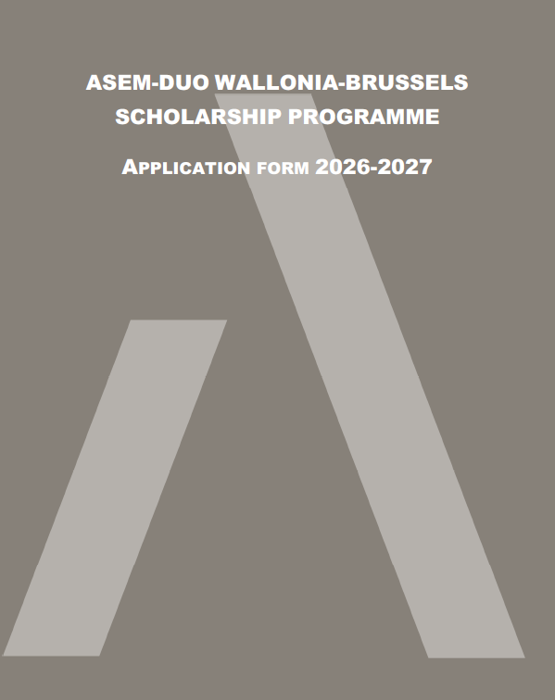

- PRELIMINARY REMARKS TO BE READ CAREFULLY
- The call for applications and a FAQ can be found online on the website of ARES.
- The information provided in this form will be treated in confidence by ARES, the home and host institutions. Data from the form may be used for DUO Wallonia-Brussels statistical purposes, but only in an aggregated and non-identifiable manner.
- The application form must be typewritten and sent as a PDF document together with the other documents composing the application file.
- Applications must be submitted between January 19th 2026 and March 13th, 2026.
- ARES will not consider:
  - applications sent without a candidate from the higher education institution belonging to the Wallonia-Brussels Federation,
  - incomplete application files,
  - applications received before January 19th, 2026, or after March 13th, 2026.
- As a reminder, the application file must be formally submitted by the contact person identified in the higher education institution belonging to the Wallonia-Brussels Federation, as one single PDF document sent to the following address: asem-duo@ares-ac.be.
- The application must contain:
  - the completed 2026-2027 application form for the ASEM-DUO Wallonia-Brussels Mobility Scholarship Programme;
  - a copy of the academic cooperation agreement between paired institutions or the declaration of intent to sign one in the two following years, signed by the authorities of both the Wallonia-Brussels and Asia-Pacific HEIs (or their representatives);
  - the resume (CV) of max 5 pages of each applicant with a focus on the job experience relevant to the ASEM-DUO programme.
- Candidates' compliance with instructions related to the application procedure will be considered when ARES assesses the admissibility of the application. Any application that does not comply with the guidelines set out in the call for applications and in this form will be considered inadmissible.

- information about candidates and their project(s)
02.1 / CANDIDATE FROM WALLONIA-BRUSSELS
General information
First name
Family name
Date of birth (dd/mm/yyyy)
Gender | Male Female Other Prefer not to say
Academic title
Name of your higher education institution
Field of study
Department, faculty
Professional address (street, n°, ZIP code, city, country)
Mobile phone
Professional e-mail

Description of the project
Title of the project
Discipline
Description of the project (max. 350 words) | The description of the project must be popularized in order to allow the members of the jury to easily understand the purpose of the project and evaluate its quality and its original character.
Description of the internationalisation of the project (objectives, expected outcomes) (max. 500 words) | This question concerns the project itself and the people directly involved. The description of the internationalisation of the project must describe the opportunities for developing collaborations that go beyond the project itself.  Applicants are invited to describe in concrete terms:  - the international dimension of the exchange project (objectives, expected outcomes, shared learning or practices);  - future opportunities for collaboration that this project could give rise to (e.g. new exchanges of students, researchers, joint projects, seminars or joint publications);  - the beneficiaries of the project (students, teachers, departments, faculties, etc.) and the concrete impacts for them;  - the envisaged sustainability of the collaboration (how the links can be maintained beyond the duration of the project).  This question relates to the individual and the specific project (individual and operational levels), not to overall institutional policy.
Purpose of the exchange (max. 150 words) | Explain the purpose of your mobility and the main activities planned during the exchange (meetings, visits, classes, conferences, etc.).  The purpose and relevance of the trip for each of the partners must be clearly specified.
Proposed duration of the exchange (minimum 18 days, maximum 60 days) and explanation of the duration (max. 150 words) | The length of the respective stays should be considered in the light of the amount of the individual scholarships, which are divided into two instalments:  - 80% of the individual scholarship paid a few days before the visit, after deduction of the cost of the flight tickets.  - 20% of the individual scholarships paid on submission of the report (after the stay),  The total amount of the per diem cannot exceed the number of days of the individual mission multiplied by the daily allowance.
Proposed date of departure (between 01/08/2026 and 31/08/2027)
Have you already received funding (from ARES or any other organisation) for this project? | Yes / No  If yes, explain (1) which funding, the purpose, the partner and when ; (2) how an ASEM-DUO scholarship complements this funding.
Have you already applied to the ASEM-DUO scholarship programme? | Yes / No  If yes, explain for which project, the partner and when.

Internationalisation project
How does the internationalisation of the project fit in with your institution's internationalisation strategy/goals? (250 words) | This question concerns how the project fits in with the institution's international strategy (institutional and strategic levels).  Demonstrate the link between your project and your institution's international strategy: how does the project fit in with institutional priorities or objectives (e.g. focus countries or regions, types of partnerships, training or research objectives, etc.).  Applicants must demonstrate that they are familiar with their institution's strategy and that their project fits into this overall approach, even if it is small in scale.
  - / CANDIDATE FROM THE ASIA-PACIFIC COUNTRY
General information
First name
Family name
Date of birth (dd/mm/yyyy)
Gender | Male Female Other Prefer not to say
Academic title
Name of your higher education institution
Field of study
Department, faculty
Professional address (street, n°, ZIP code, city, country)
Mobile phone
Professional e-mail

Description of the project
Title of the project
Discipline
Description of the project (max. 350 words) | The description of the project must be popularized in order to allow the members of the jury to easily understand the purpose of the project and evaluate its quality and its original character.
Description of the internationalisation of the project (objectives, expected outcomes) (max. 500 words) | This question concerns the project itself and the people directly involved. The description of the internationalisation of the project must describe the opportunities for developing collaborations that go beyond the project itself.  Applicants are invited to describe in concrete terms:  - the international dimension of the exchange project (objectives, expected outcomes, shared learning or practices);  - future opportunities for collaboration that this project could give rise to (e.g. new exchanges of students, researchers, joint projects, seminars or joint publications);  - the beneficiaries of the project (students, teachers, departments, faculties, etc.) and the concrete impacts for them;  - the envisaged sustainability of the collaboration (how the links can be maintained beyond the duration of the project).  This question relates to the individual and the specific project (individual and operational levels), not to overall institutional policy.
Purpose of the exchange (max. 150 words) | Explain the purpose of your mobility and the main activities planned during the exchange (meetings, visits, classes, conferences, etc.).  The purpose and relevance of the trip for each of the partners must be clearly specified.
Proposed duration of the exchange (minimum 18 days, maximum 60 days) and explanation of the duration (max. 150 words) | The length of the respective stays should be considered in the light of the amount of the individual scholarships, which are divided into two instalments:  - 80% of the individual scholarship paid a few days before the visit, after deduction of the cost of the flight tickets.  - 20% of the individual scholarships paid on submission of the report (after the stay),  The total amount of the per diem cannot exceed the number of days multiplied by the daily allowance.
Proposed date of departure (between 01/08/2026 and 31/08/2027)
Have you already received funding (from ARES or any other organisation) for this project? | Yes / No  If yes, explain (1) which funding, the purpose and when ; (2) how an ASEM-DUO scholarship complements this funding.
Have you already applied to the ASEM-DUO scholarship programme? When? | Yes / No  If yes, explain for which project, the partner and when.

Internationalisation project
How does the internationalisation of the project fit in with your institution's internationalisation strategy/goals? (250 words) | This question concerns how the project fits in with the institution's international strategy (institutional and strategic levels).  Demonstrate the link between your project and your institution's international strategy: how does the project fit in with institutional priorities or objectives (e.g. focus countries or regions, types of partnerships, training or research objectives, etc.).  Applicants must demonstrate that they are familiar with their institution's strategy and that their project fits into this overall approach, even if it is small in scale.
  - / COMPLEMENTARITY
Complementarity – TO BE FILLED JOINTLY BY THE CANDIDATES
Describe the expected benefits of your internationalisation project on the (further) development of the links between your institution and the partner institution (max. 200 words) | As the ASEM-DUO programme aims to create and develop collaborations between institutions in the FWB and the Asia-Pacific region, applications with significant potential for developing collaboration between partner institutions will be given priority.  This question aims to measure the lasting impact of the project on the relationship between the two partner institutions (interinstitutional and partnership level).  Applicants must specify:  - how the project will strengthen or deepen cooperation between the two institutions (e.g. formalisation of a partnership, extension to other departments, creation of a framework agreement or a new programme);  - what medium- or long-term prospects may result for the two institutions.
Description of how the projects submitted complement each other (if the projects are different) (max. 150 words) | The projects of the partners in the duo may be different. Nevertheless, the complementary nature of the projects must be precisely described and will be considered in the assessment of the application by the members of the jury.
- Contact Person in the Higher education institutions
In each higher education institution, a contact person must be clearly identified. The contact person should ideally be the institution’s representative for international relations. The contact person in the Wallonia-Brussels higher education institution is responsible for sending a complete application, including the documents for both applicants.
03.1 / CONTACT PERSON IN THE WALLONIA-BRUSSELS HIGHER EDUCATION INSTITUTION
Contact information
Title
First name
Family name
Status/Position
Address of the institution (street, n°, ZIP code, city, country)
Phone
E-mail
  - / CONTACT PERSON IN THE ASIA-PACIFIC HIGHER EDUCATION INSTITUTION
Contact information
Title
First name
Family name
Status/Position
Address of the institution (street, n°, ZIP code, city, country)
Phone
E-mail
- CERTIFICATION
I hereby certify that the information provided in this application is correct and complete and confirm that the applicants have read the call for applications and regulations of the ASEM-DUO Wallonia-Brussels programme, and will abide by the terms and conditions specified in this call if they are selected. Any provision of inaccurate or false information or omission of information will render this application invalid and that, if selected on the basis of such information, the applicants can be required to withdraw from the grant.
I hereby certify that the project(s) which is/are the subject of this scholarship are being carried out with the intention of respecting human rights. In the event that the project(s) address(es) sensitive areas such as technology or intellectual property, particularly in military contexts, I am fully aware of the risks inherent in these sensitive subjects, linked to the dual use and misuse of research, and if requested by my institution, I received the approval from the relevant authorities.
Name and Signature of the Asia-Pacific candidate
Name
Date
Signature

Name and Signature of the authorities of the Asia-Pacific higher education institution
Name
Date
Signature

Name and Signature of the Wallonia-Brussels candidate
Name
Date
Signature

Name and Signature of the Wallonia-Brussels higher education institution
Name
Date
Signature
- Consent to data treatment
☐ I expressly consent to ARES processing my personal data in connection with this application and in connection with the ASEM-DUO programme.
If you have any questions, you can contact the data controller and the Data protection Officer at the following e-mail address vieprivee@ares-ac.be and consult the ARES privacy page.
---------------------

